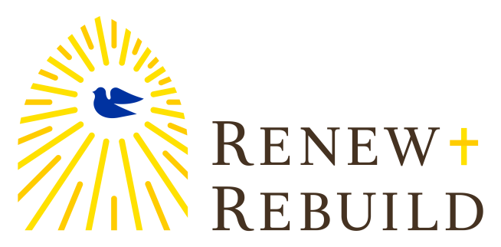

Renew + Rebuild Capital Campaign has begun at
Our Lady of Sorrows Parish.
Renew + Rebuild is an initiative to address serious needs for all 292 parishes of the Archdiocese of New York.
Our parish goal is $1,421,500 which will address the initiatives below.
1. New School Boiler and
Heating System
2. New Convent Boiler and
Heating System
Our 2017 Cardinal's Appeal is included in this campaign.
3. Replace Gymnasium Roof
and Windows

6. Establish Parish Facilities
Maintenance Fund
5. Replace School and
Convent Sidewalks
4. Replace and Resurface
School and Convent
Parking Lots

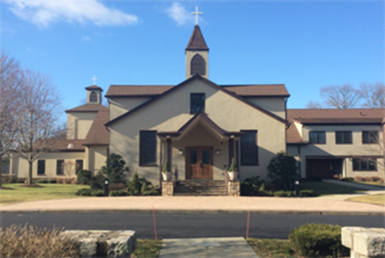
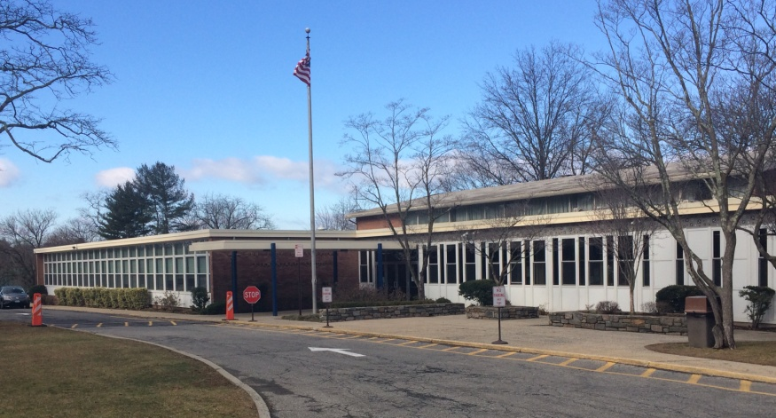

Thankfully, we have already raised over $500,000 in 5 year-pledges!

We invite you to prayerfully consider a significant pledge to our campaign. It will provide momentum to Our Lady of Sorrows Parish and inspire confidence in our vision for the future.
            

Every member of Our Lady of Sorrows should have received campaign materials in the mail. If you have not please pick up a packet at the rectory. You can also make a pledge online at www.renewrebuild.org.

